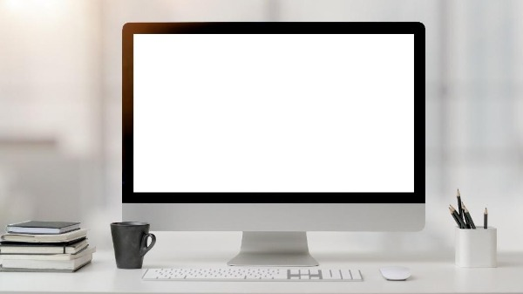

I chose this object because it has a lot of shapes, but I really like the idea of using bump maps on low poly shapes. For instance, you could use boxes on the keyboard and use a lot of vertices, or you could add a bump map to the table and fake geometry for a negligible performance boost. You could also slightly add a bump map to the screen for extra geometry as well.

Assuming I add a bump map to these or could even figure out how to apply something like that in OpenGL, I would add a lot of boxes for various parts of the screen. You can make a flat, thin box with rounded edges for the screen. For the stand, you can make a plain with eight vertices. From there, grab all but the bottom two vertices and scale the distance down evenly. De-select the two vertices closest to the unmodified ones, then scale those vertices down as well. You can then bend the bottom two vertices to 90 degrees from the second row. You can then bend the top row of vertices into the monitor after placing it in the appropriate spot.

The cup would require three shapes. A cylinder for the cup and a taurus for the handle. You would need to delete the face on the top of the cylinder and skew the bottom plain to mimic the shape of the cup. You would then need to cut the taurus in half, then connect the ends to a single vertex directly proportional to the open end of the taurus. You could connect it to the cup at that point or sculpt it more to look better. The cup then requires a copy of the cylinder shape that is slightly scaled down and placed uniformly in the cup. Flip the normals of the new cup and connect the unconnected edges at the top between both cylinders.

The books would require four boxes. Two flat boxes sandwiching a larger flat box, with an extra along the back in the shape of the book’s spine. They can then be scaled up and down, copy and pasted on each other to match the shape of the book stack.

The pencils are cylinders with an extra vertex added to the top of one side and extra edges added from the new vertex to the ones on the outer rim of the face where the new vertex was added. The new vertex is then moved directly away from the cylinder until a 20-degree point is made.

The mouse is wireless and is a long box with extra vertices subdivided. Smooth out corners and move the top plain into an arc.

The pencil cup is two cylinders but one with flipped normals much like the cup above.

The background is a sphere with the normal facing inwards. You can apply a blurry image texture color and keep the camera inside.